**Scala Installation**

**NAME: MUTTA DATTA SAI VISHNU MOHAN**

**USN: 22BTRAD026**

Step 1: Download and install Java.

<https://www.java.com/en/download/manual.jsp>

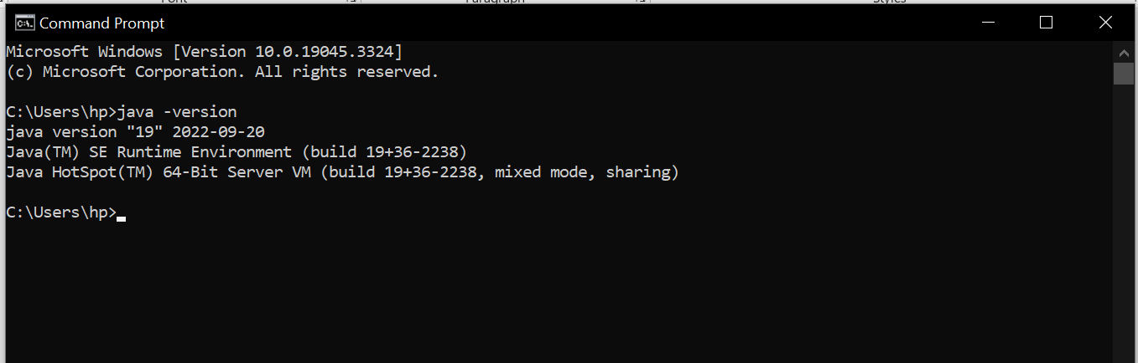

Step2: Download and install Scala <https://www.scala-lang.org/download/><https://www.scala-lang.org/download/2.13.11.html>

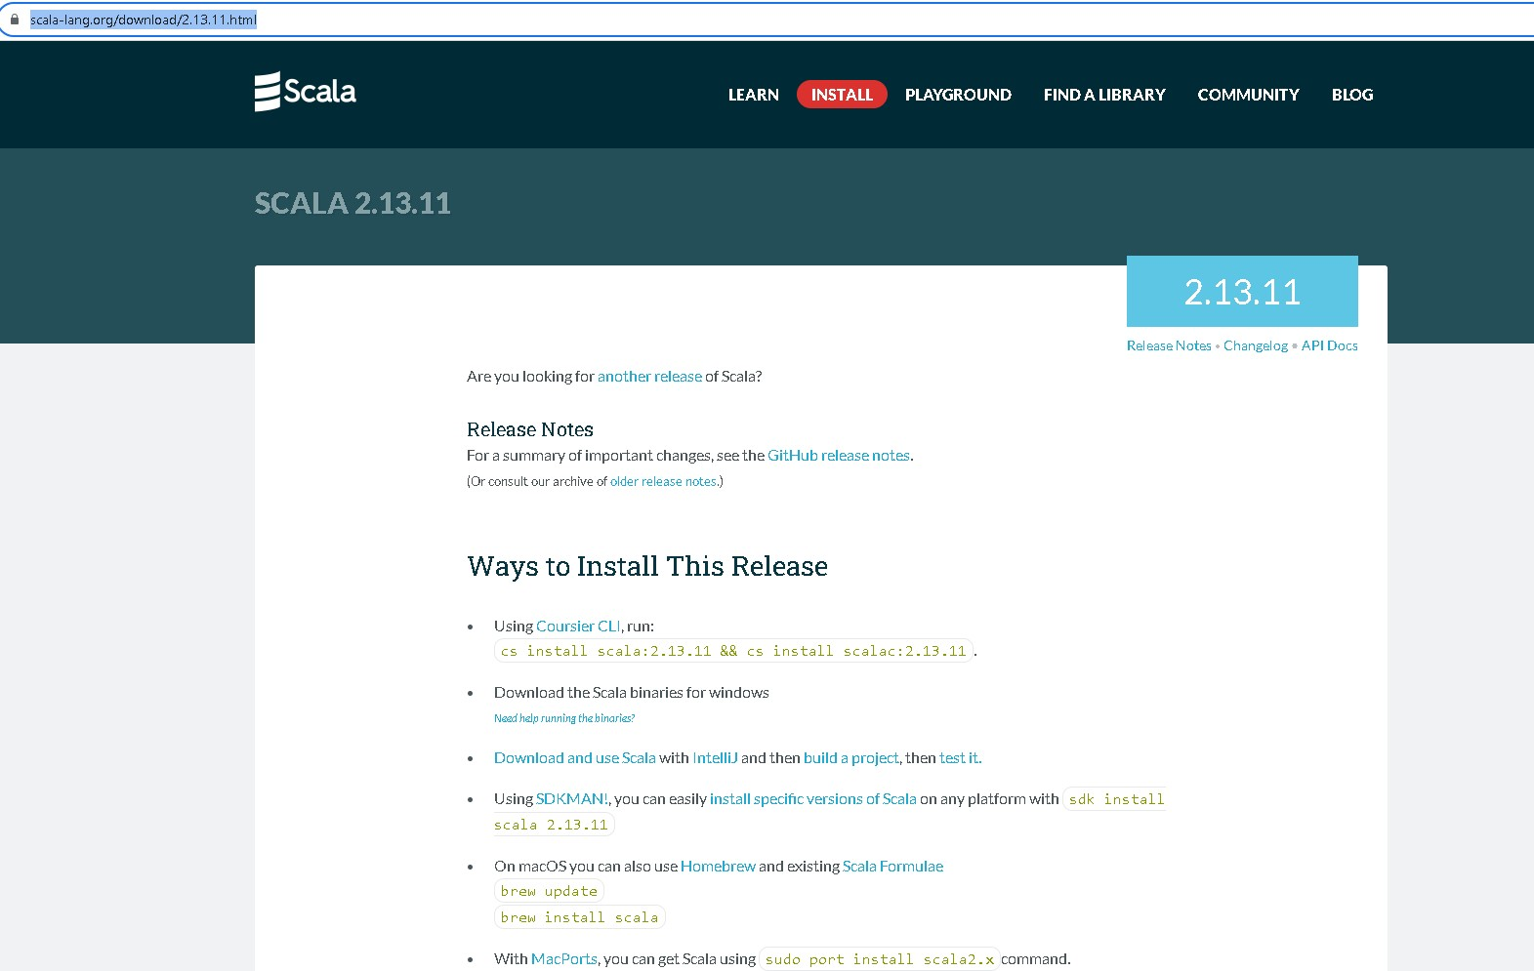

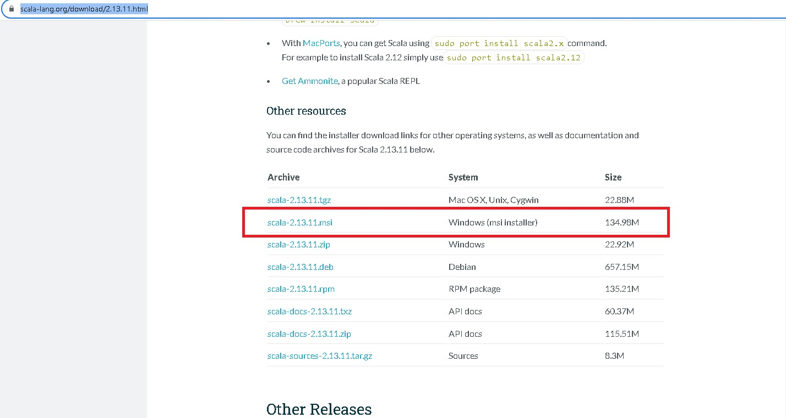

Install msi version.

Step3: Open **Edit the System Enviornment And Variables**

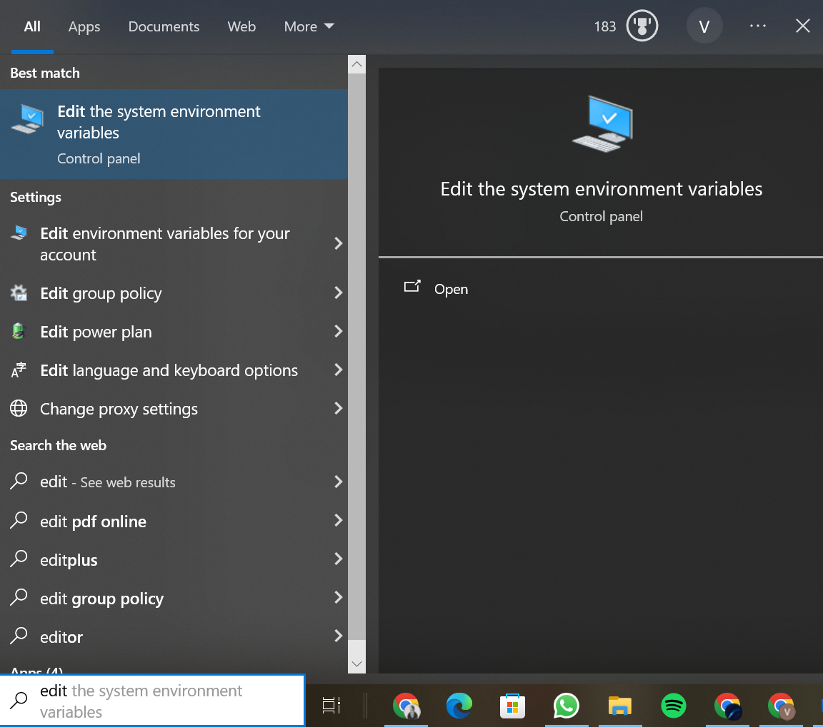

Step4: Click on Enviornment Variables.

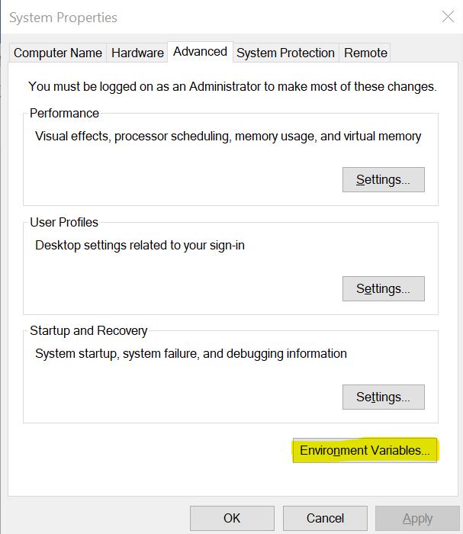

Step 5: Click on Path

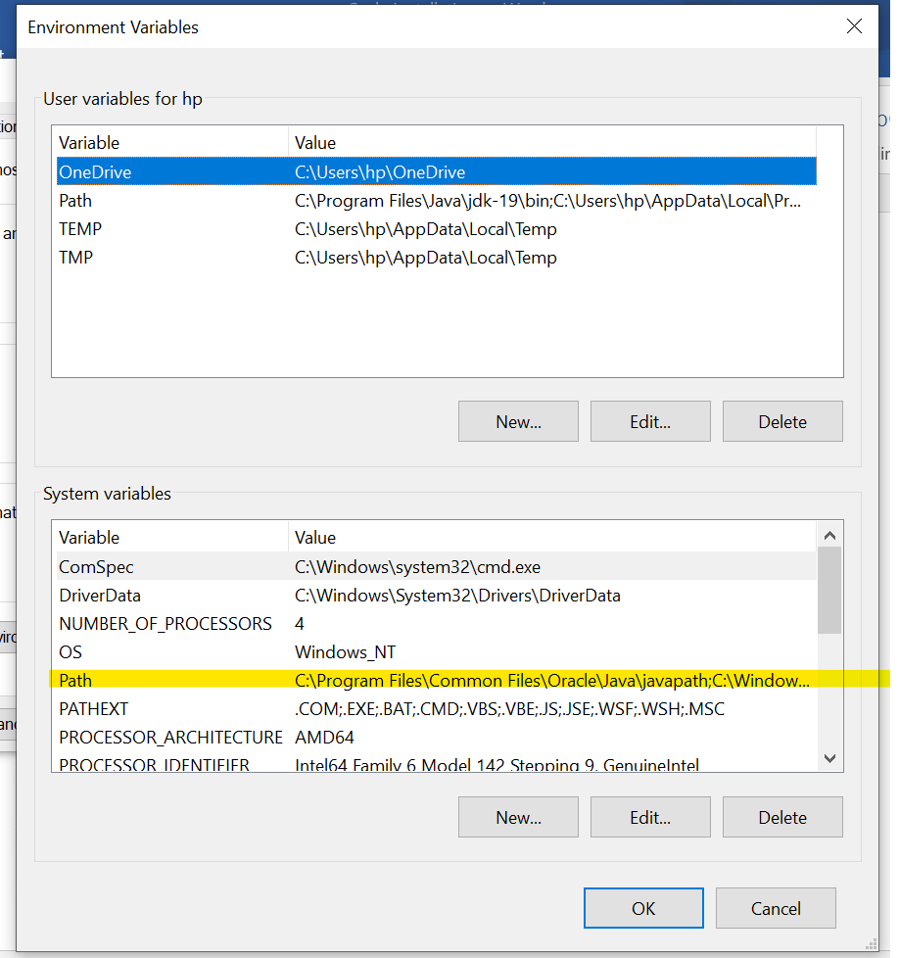

Step 6: Click on Edit

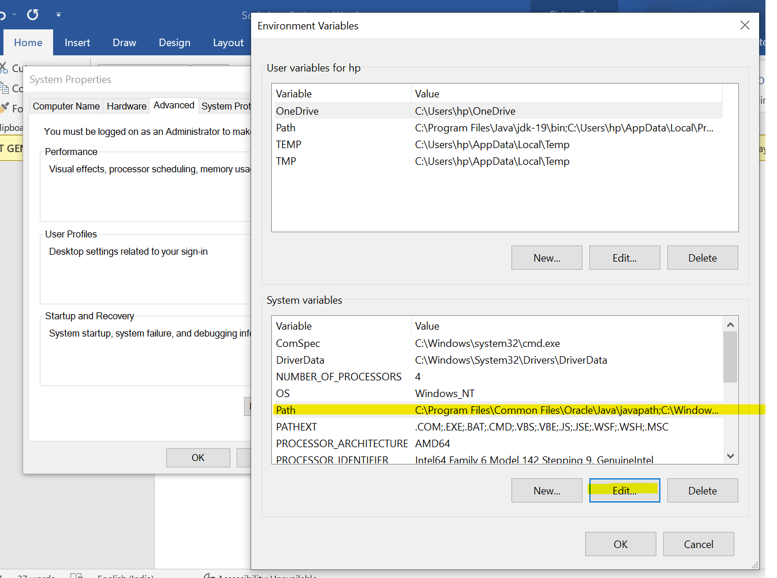

Step7:Click on new and add path

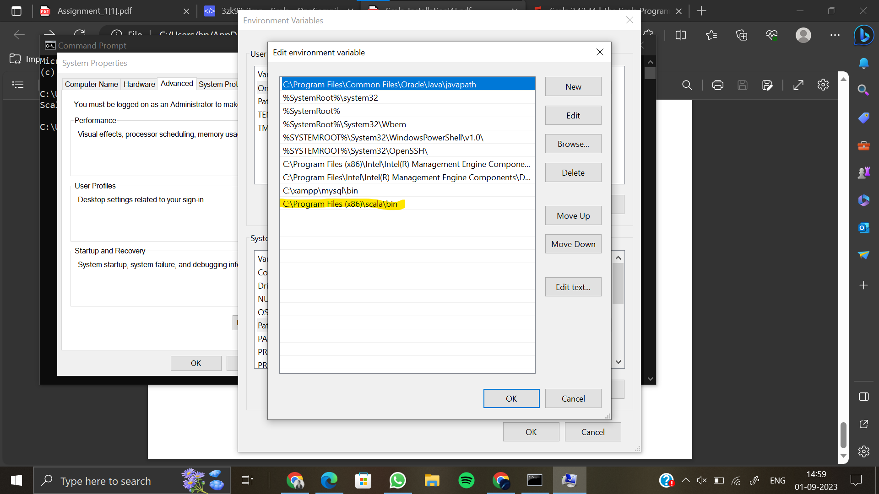

Scala is installed at this path.

Confirm the version with cmd .

